Unit 3: Thermochemistry test Name: _________________ Mark: /50

SECTION A – Multiple-choice questions

Instructions for Section A
Answer all questions.
Choose the response that is correct for the question.
A correct answer scores 1, an incorrect answer scores 0.
Marks are not deducted for incorrect answers.
If more than one answer is completed for any question, no mark will be given.

Use the following information to answer Questions 1,2 and 3
The energy profile diagram below is for the reaction between CO₂ and H₂O to form methane and oxygen.
CO₂(g) + 2H₂O(l) CH₄(g) + 2O₂(g)
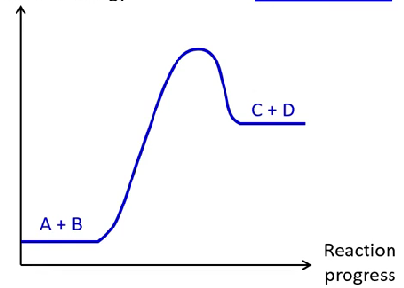

220 kJ

1010 kJ

Question 1
Select the correct statement about the energy change occurring in this reaction.

A. The sign of the activation energy will be a negative.
B. The surroundings will become warmer as this reaction proceeds.
C. The enthalpy of the reactants is greater than the enthalpy of the products.
D. Energy required to break reactant bonds is greater than the energy released forming products

Question 2
The activation energies of the forward and back reactions are

A. forward: 220 kJ reverse: 1010 kJ
B. forward: 1230 kJ reverse: -220 kJ
C. forward: 1010 kJ reverse: 220 kJ
D. forward: -790 kJ reverse: 220 kJ
Question 3
The water used in the reaction above is replaced with steam. As a result of this change in the state of one of the reactants,

A. the activation energy and the ΔH value will not change.
B. the activation energy will be lower and the ΔH value will be lower.
C. the activation energy will be lower but the ΔH value will not change.
D. the activation energy will be higher and the ΔH value will not change.

Question 4
Select the correct statement about the combustion of ethane.

A. The molar enthalpy of ethane is -286 kJ g⁻¹.
B. The amount of energy released when one mole of ethane is combusted is -1560 kJ.
C. 52 kJ of energy is released when 1.0 g of ethane is combusted.
D. 3120 kJ of energy is released when one mole of ethane is combusted.

Question 5
The specific heat capacity of ethanol is 2.57 kJ g⁻¹ ⁰C⁻¹. The energy required to raise the temperature of ethanol by 10 ⁰C will cause the temperature 1.0 g of water to change by

A. 6.1 ⁰C
B. 8.0 ⁰C
C. 10.0 ⁰C
D. 16.3 ⁰C

Question 6
The energy produced by the complete combustion of 0.050 mol of a fuel is 78 kJ. The fuel is

A. methanol
B. ethane
C. ethanol
D. propane

Use the following information to answer Questions 7 and 8
The thermochemical equation for the reaction between nitrogen and oxygen gases to form nitrogen dioxide is

N₂(g) + 2O₂(g) 2NO₂(g) ΔH = 66.4 kJ

80 mL of nitrogen is reacted with 110 mL of oxygen. Both gases were stored at SLC. After reaction the products and excess reagent were returned to SLC.

Question 7
After the reaction the volumes of gas present at SLC is/are

A. 160 mL of NO₂ only
B. 160 mL of NO₂ and 30 mL of O₂
C. 55 mL of NO₂ and 25 mL of N₂
D. 110 mL of NO₂ and 25 mL of N₂

Question 8
When this reaction occurred

A. 0.15 kJ of energy was required.
B. 0.30 kJ of energy was required.
C. 0.15 kJ of energy was released.
D. 0.30 kJ of energy was released.

Question 9
0.46 of ethanol is burnt under a can containing 250 g of water. The temperature change of the water is 10.0 ⁰C. The efficiency of the energy transfer is

A. 53%
B. 64%
C. 67%
D. 77%

Question 10
A food bar containing an equal mass of protein, carbohydrate and fat releases 210 kJ of energy when digested.
The mass of the food bar is

A. 3.0 g
B. 6.0 g
C. 9.0 g
D. 12.0 g

SECTION B- Short-answer questions

Instructions for Section B
Questions must be answered in the spaces provided in this book.
To obtain full marks for your responses you should
- Give simplified answers with an appropriate number of significant figures to all numerical questions; unsimplified answers will not be given full marks.
- Show all workings in your answers to numerical questions. No credit will be given for an incorrect answer unless it is accompanied by details of the working.
Make sure chemical equations are balanced and that the formulas for individual substances include an indication of state; for example, H₂(g); NaCl(s)

Question 1 (13 marks)
The diagram below is used to illustrate the energy changes occurring when a wood fire is used to heat a room. (The main component in wood is shown as cellulose, a polymer of glucose (C₆H₁₂O₆)_{n}).
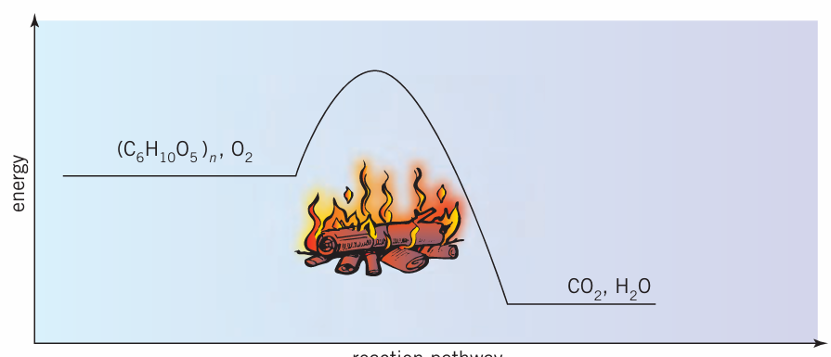
reaction progress

a. i. List the bonds that need to break for combustion to occur. 2 marks

___________________________________________________________________________

___________________________________________________________________________

ii. List the bonds that form in this reaction. 2 marks

___________________________________________________________________________

___________________________________________________________________________

iii. How will the energy required to break the bonds in wood compare to the energy released
when products form? Justify your answer. 2 marks

___________________________________________________________________________

___________________________________________________________________________

b. Annotate the diagram to show the activation energy and enthalpy change for this reaction.
2 marks

c. i. State a reason why the ΔH value for this combustion is not a precise one. 1 mark

___________________________________________________________________________

ii. Explain why incomplete combustion of wood is an issue. 2 marks

___________________________________________________________________________

___________________________________________________________________________

iii. Discuss the use of wood being used as a home heating fuel to preserve limited fossil fuel
reserves. 2 marks

___________________________________________________________________________

___________________________________________________________________________

___________________________________________________________________________

___________________________________________________________________________

Question 2 (8 marks)
Methanol is commonly used as a fuel. It is a liquid at room temperature with a density of 0.78 g mL⁻¹.

a. Write a thermochemical equation for the complete combustion of methanol. 2 marks

___________________________________________________________________________

b. Determine the heat of combustion of methanol in

i. kJ mol⁻¹ ______________________________________________________ 1 mark

ii kJ g⁻¹ _______________________________________________________ 1 mark

iii. kJ L⁻¹ __________________________________________________________ 2 marks

_______________________________________________________________

c. Determine the mass of methanol required to produce 1.0 GJ of energy. 2 marks

___________________________________________________________________________

___________________________________________________________________________

Question 3 (10 marks)
Butane is a component of LPG gas and it is used in camping cooking stoves. The equation for the reaction of butane and oxygen is

2C₄H₁₀(g) + 13O₂(g) 8CO₂(g) + 10H₂O(g)

a. 60 L of butane and 450 L of oxygen, both hat SLC, are reacted.

i. Which gas is in excess? 2 marks

___________________________________________________________________________

___________________________________________________________________________

___________________________________________________________________________

ii. Determine the volume at SLC of greenhouse gas produced in this reaction. 2 marks

___________________________________________________________________________

___________________________________________________________________________

iii. Determine the mass of reactant remaining. 2 marks

___________________________________________________________________________

___________________________________________________________________________

b. 1.0 kg of butane undergoes complete combustion.

i. Determine the mass of CO₂ produced. 3 marks

___________________________________________________________________________

___________________________________________________________________________

___________________________________________________________________________

___________________________________________________________________________

ii. Determine the amount of energy released. 1 mark

__________________________________________________________________________

__________________________________________________________________________

Question 4 (9 marks)
The apparatus below is used to determine the energy content of a cracker biscuit.
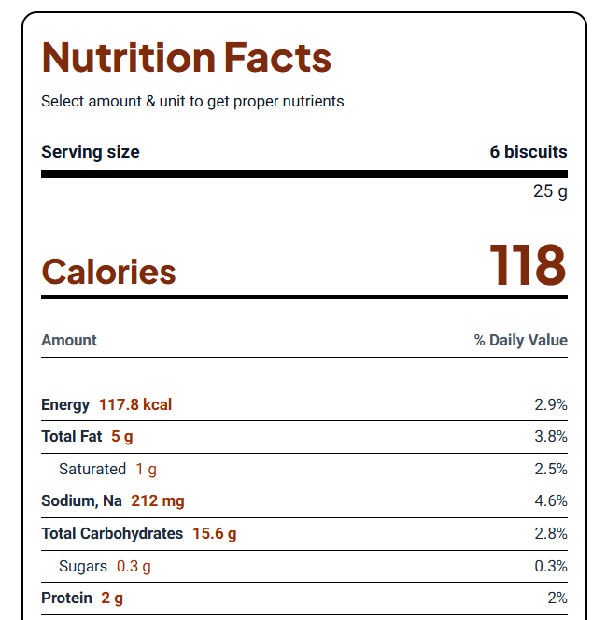
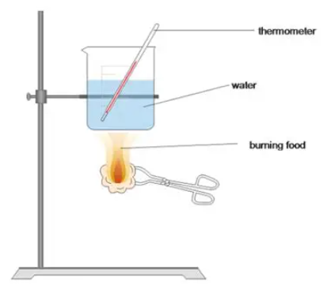

In one trial the following data is recorded:

Mass of biscuit 1.28 g
Mass of water 140 g
Initial temperature of water 19.6 ⁰C
Final temperature of water 31.1 ⁰C

a. Use the measurements provided to determine the energy density of the cracker. 3 marks

__________________________________________________________________________

__________________________________________________________________________

__________________________________________________________________________

__________________________________________________________________________

b. Use the food content breakdown of the cracker and your data book to determine the theoretical
energy density of the cracker. 2 marks

__________________________________________________________________________

__________________________________________________________________________

__________________________________________________________________________

c. Discuss the difference between the values obtained in parts a. and b. 2 marks

__________________________________________________________________________

__________________________________________________________________________

__________________________________________________________________________

d. Suggest two design changes that could be made to this experiment to improve the accuracy of
the values obtained. 2 marks

__________________________________________________________________________

__________________________________________________________________________

__________________________________________________________________________

END OF TOPIC TEST

